FOR IMMEDIATE RELEASE
SAINT JOHN’S CATHOLIC PREP HONORS MARLENE YOUNG,
PRESIDENT OF DELAPLAINE FOUNDATION, Inc. AS PRESIDENTIAL HONOREE
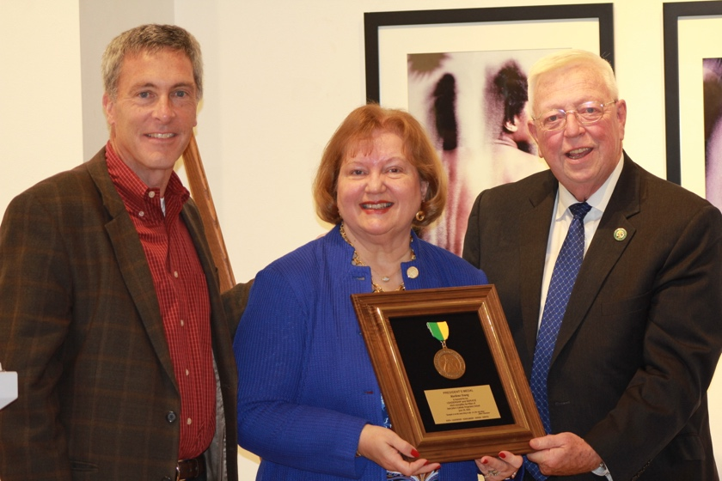
(Pictured Left to Right), Jim Plamondon, Chairman of the Board of Trustees at Saint John’s Catholic Prep,
Marlene Young, President of Delaplaine Foundation, Inc and Dr. Thomas Powell, President of Saint John’s Catholic Prep
Frederick, Md (November 13, 2020) – Saint John's Catholic Prep High School (SJCP) Dr. Thomas H. Powell honored Marlene Young, President of Delaplaine Foundation, Inc., as a recipient of the 2020 Presidential Medal Honoree in a private ceremony at the Delaplaine Arts Center on Friday, November 13, 2020. “We had originally planned to honor Marlene at Saint John’s Catholic Prep’s 187th Commencement Ceremony, which was postponed and finally celebrated at Nymeo Field at Harry Grove Stadium on the morning of Saturday, June 20, 2020. Due to COVID-19 there were limited attendees, so we decided we needed to go to Marlene in order to properly honor her. Honoring Marlene is a long overdue for her outstanding work in our community; this is a very well-deserved honor.” shared Dr. Thomas Powell
Dr. Powell, Chairman of the SJCP Board of Trustees, Jim Plamondon, board members and staff of Delaplaine Foundation, Inc., Marlene’s husband Mike, and friends gathered for the ceremony in her honor. Dr. Powell shared, “When I think of Marlene, I am reminded of a quote of one of my heroes, Dr. Albert Schweitzer, ‘Example is not the main thing in life…it is the only thing in life.’ Marlene Young is an inspirational example for our students and our entire community. She has made a significant difference in so many lives, and her leadership has improved our community and our Nation. May we all be inspired by her commitment to serve and tonight we celebrate all that she has accomplished.”
Marlene B. Young is President of Delaplaine Foundation, Inc., a private foundation to the enrichment of communities and families by supporting programs that strengthen education, arts and sciences, historical preservation, spiritual enlightenment, and physical well-being. Additionally, she is Vice President of Great Southern Enterprises, Inc., a management services firm in Frederick specializing in venture capital funding and public and private investment.

With a career in corporate administration and a background in publishing and telecommunications, Ms. Young is a five-time recipient of the Maryland Department of Labor, Licensing and Regulation’s Outstanding Media Award for her ongoing efforts in support of the Maryland Job Service. She is likewise the recipient of the Founders Club Award from the Maryland-Delaware-DC Telecommunications Association for her contributions to the cable industry of over twenty-five years.
In 2005 Ms. Young was an investor in Great State Publishing Co., publishers of Maryland Life magazine, Maryland’s premiere statewide magazine of record which published from 2005 through 2013 during which time, Young served as Chair of The Maryland Board, a 90-member statewide Board comprised of top profile individuals from Maryland’s 23 counties, plus Baltimore City. A primary function of The Maryland Board was the coordination of the annual selection and recognition of the Marylander of Distinction Award and Young chaired the annual event which recognized the accomplishments of outstanding Marylanders who have made multi-dimensional contributions to the State, including J.W. Marriott, Dr. Ben Carson, and others.
In 2008 she was named a Paul Harris Fellow by The Rotary Foundation of Rotary International in recognition of community service and human relations. She was awarded an honorary Doctorate of Humane Letters degree by Hood College in 2014 in recognition of her leadership, her long-term support of the college and community contributions and positive impact in Frederick County and the State. She was selected for members in the National Association of Professional Women in 2014 for excellence and dedication to her profession and the advancement and achievement of professional women. Additionally, she received the Inspirational Woman of the Year Award in 2014 by Women’s Radio Network. She received the Community Volunteer Award from the United Way in 2014 for her efforts on behalf of service to others. She was named one of Maryland’s Top 100 Women in 2015 and recently honored again in 2020 for a second time.
Ms. Young serves on the Board of Trustees of Hood College where she is also Chair of the Institutional Advancement Committee. She is a “founding mother” of the Maryland Women’s Heritage Center in Baltimore and is a charter member of the Women’s Giving Circle of Frederick County, having served two terms as Grants Committee chairperson, and has served on numerous community boards within the region
Mrs. Young and her husband Mike are involved in multiple community activities through service and philanthropic giving. The Youngs have established the Young Scholars Award through the Community Foundations of both Frederick County and Washington County to benefit high school students at Middletown High School and Smithsburg High School who are going on to major in business, education or music. Likewise, they have established two scholarships at Hood College, her alma mater, for students majoring in business, education, music or the humanities. Young has been a strong advocate and mentor for student recipients of the scholarship awards. She has also been a strong supporter of women in business and community through the Woman-To-Woman Mentoring association in Frederick County. The Youngs have been proud to be involved with the Carson Scholars Fund since 2008 and have funded Carson Scholars since that time at Wolfsville Elementary School where in 2013 they funded the establishment of a Ben Carson Reading Room for students. Young is a champion for literacy in all ages of life.
.

Mrs. Young is an accomplished recording artist, having released seven CD albums of holiday, gospel and inspirational music. She has served as a Choir Director, Director of Music, Music Coordinator, certified Lay Servant, and Adult Sunday School teacher in the United Methodist Church. For the Youngs, their faith, family and friends are the source of their greatest joy.
Marlene graciously received the honor and once again inspired us by her words. She shared she is so thankful for the many opportunities she has received over the years living and working in the greater Frederick community. She reminded us as we face the trials of today with COVID-19, “We must remember not to allow tough times to define us, but only refine us.” Marlene continued to thank Delaplaine Foundation, Inc. board members and staff that were present and work tirelessly with her to serve the community. She shared she often reflects on her favorite bible verse, ‘Luke 12:48, To whomever much is given, much will be required.’
Marlene also thanked George Delaplaine, Jr. for the trust and confidence he has placed in her and for supporting her over the years to become the successful woman she is today. She shared one of the greatest lessons she learned from George and Bettie Delaplaine’s example, ‘It is not only important to watch the bottom line, but more importantly to watch humankind.’ and they have been a powerful example for her over the years.
Marlene went on to share what an honor it has been to serve in this incredible community and thanked God for the many wonderful people he has placed in her life. Marlene Young and her husband Mike have a daughter and a son and their spouses, and six grandchildren.

About Saint John’s Catholic Prep
Saint John’s Catholic Prep, the oldest Catholic High School in Maryland founded in 1829. Saint John’s Catholic Prep is a private, Roman Catholic, coeducational, college preparatory high school located on over 60 acre’s campus in Buckeystown, Maryland, south of Frederick, Maryland. As Frederick’s area Premier College Prep High School Saint John’s Catholic Prep is dedicated to the development and education of the total student to foster a commitment to academic excellence, service and leadership while inspiring lifelong learners and the development of future servants for their communities. Saint John’s Catholic has an 100% College Acceptance Rate and offers a Guaranteed College Acceptance & Scholarship Program as well as Mount St. Mary’s Dual Credit Partnership.

